Week 6 Pre-Lab (Endpoints)
Pre-Labs should be submitted to Canvas BEFORE that week’s lab session.

Remember that each endpoint needs:
- Properly defined requests in the yml file
- Python scripts to execute the required function
- (Sometimes you need to install more libraries, depending on the scripts you right. If you have to install something new, update the requirements.txt file!)

- /prediction endpoint (5 points)
  - Create a /prediction endpoint in your master.yml file. This file should be a POST that allows someone to upload a file to the server (like testdata.csv) and return a list of resulting predictions. Use the appropriate syntax. I recommend you doing this in your Swagger Editor and copy/paste your VM master.yml file when complete.
  - Note there a file_predict function in model.py (see below). It is not finished as it needs YOUR model to be loaded. This means you need to make sure your pkl file is in the same directory (src folder) as this script). Make those updates (HINT: Use your upload file endpoint to get your model pkl file onto your VM).
  - Test your service. Make sure that any installations are updated in your requirements.txt file.
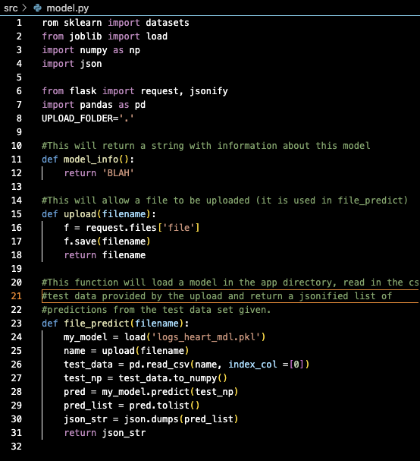
- /performance endpoint (5 points)
  - Create a /performance endpoint that provides accuracy or whatever performance metric you used to the user.
  - No function has been created to do this. You will need to either create a new py file OR include it in the model.py script.

